Product Manual
Medical infrared thermometer
FQ-V011

- Please read the manual before use to ensure safety.
- Please keep it properly for future reference.

CONTENTS
1. Attention 2
2. Product Introduction 3
3. Product classification 3
4. Scope 3
5. Working Principle 3
6. Features 3
7. Product Picture 4
8. Components 4
9. Screen Description 4
10. Setting Operation 5
11. Measurement Method 7
12. Battery Installation and Replacement 8
13. Maintenance 8
14. Storage and Transportation Conditions 9
15. Troubleshooting 9
16. Technical Parameters 10
17. Explanation for Symbols 10
18. Warranty and After-sales Service 11
19. List of Items 11

Dear user,
● Thank you for purchasing this product.
● Please read the manual carefully before use.
● Please keep this manual in a safe place after reading it.
● Please keep the proof of purchase for future repairs.

Attention
 Please read the manual carefully before use and ensure that the battery is installed.
DO NOT immerse any part of the product in water or other liquids, as it may get damaged. Follow the instructions on cleaning and disinfection to clean it.
DO NOT disassemble or repair it yourself, as it may get damaged.
Keep it out of the reach of children.
DO NOT expose it to high or low humidity for a long time.
DO NOT mix it with sharp objects, and place it in a safe place to avoid impact and drop.
DO NOT touch the top of the temperature probe with your fingers.
DO NOT take the temperature within 30 minutes after exercise, meal, or bath, as the body temperature is inaccurate under such conditions.
In the case of significant change in the ambient temperature (such as from indoor to outdoor), please wait for about 30 minutes in the new environment before use.
Keep an interval of 10s or more for continuous measurements.
Practice several times to get yourself familiar with the measurement method and this will ensure that it produces the correct result.
Contraindications: None identified yet.

Tips
The measurement results of this product are not intended to substitute physician diagnosis.
The result may show 0.1-0.2degree difference from clinical result due to individual differences. In this case please measure other parts or refer to your doctor's order.
Used batteries should not be discarded and shall be sent to the designated place according to local environmental protection agency's requirements to avoid causing pollution to the environment.
If it is not to be used for a long time (more than 2 months), please take out the battery to avoid damage to the thermometer due to possible battery leakage.
Heed the Warnings, Attention and Tips sections to make sure that it is used properly.
DO NOT use it in an environment with strong electromagnetic interference.

Product Introduction
This product takes the temperature by collecting infrared thermal radiation emitted from the forehead. It is easy to use and produces accurate result quickly. The user only needs to point the probe at the forehead and then press the thermometer probe to obtain the temperature. It is widely used in schools, customs, hospitals, and homes.

Product classification
This product comes with an internal power supply, and is a type B, IPX0 device. It can work continuously and shall not be exposed to flammable anesthetic gas, or the mixture of air with oxygen or nitrous oxide.

Scope
● Working methods: It take the temperature by measuring the heat radiation from the forehead.
● Intended for: infants, children and adults.
● Expected usage scenarios: homes, hospitals, clinics, schools, institutions.

Working Principle
Any object emits infrared radiation, and its surface temperature determines the amount of the radiation energy and the wavelength. Based on this principle, the product uses a high-precision infrared sensor specially designed for detecting the infrared radiation with a wavelength of 5-14um emitting from human body, and can accurately measure the temperature through compensation and correction.

Features
●High-precision infrared sensor with stable and reliable performance.
● Advanced probe structure ensuring accurate result.
● Fever promoted
● Ambient temperature detected.
● Large LED screen showing the content clearly.
● Auto Power Off to save energy.

Product Picture

- Infrared probe 2-LCD display 3- - button
4- + button 5- MODE button 6-Measure switch
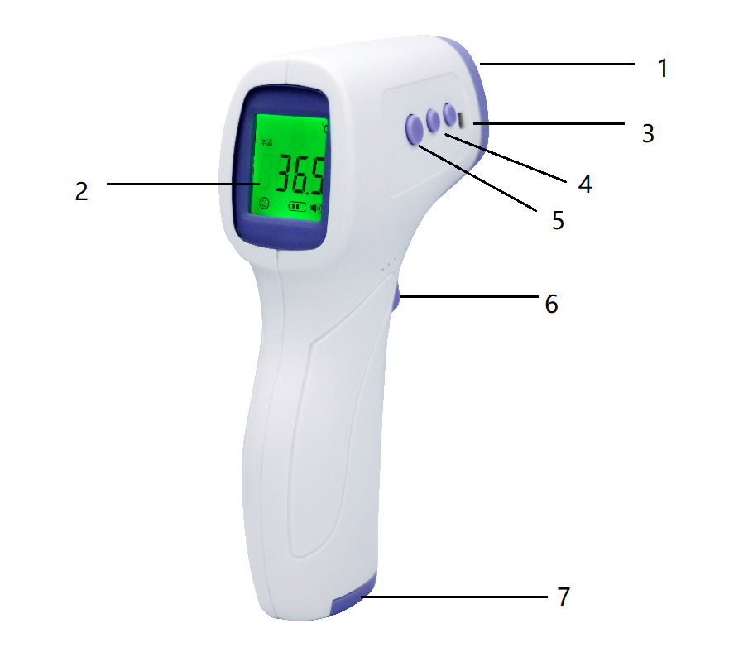
7-Battery cover

Components
This product is mainly composed of infrared sensor, distance sensor, microprocessor, memory, power supply, electro-acoustic components, LCD screen and housing.
Accessories: manual, warranty card, certificate of conformity.

Screen Description

Item | No | Description
Measurement mode | 1 | Display the measurement mode
Temperature | 2 | Display the temperature
Battery status | 3 | Show the sign | Low battery
Battery status | 3 | No sign | Sufficient battery
Storage info | 4 | Number of temperatures stored
Temperature Unit | 5 | Celsius
Temperature Unit | 5 | Fahrenheit
Beep | 6 | Show the sign | ON, with the prompt sound
Beep | 6 | No sign | OFF, without the prompt sound
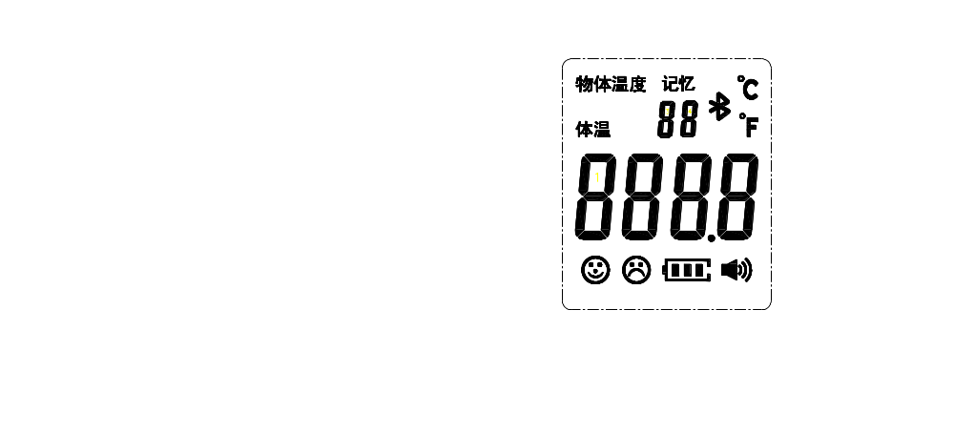
1
2
4
5
6
3
1
2
4
5
6
3
1
2
4
5
6
3

Surface temp
Memory

1
2
4
5
6
3
Body

10. Setting Operation
This product provides five function settings, including temperature unit, tone ON/OFF, temperature alarm point, temperature shift, and measurement mode. The measurement mode is set using the mode switching key; others are set in the setting menu.
Below is the setting menu comparison table:
Menu | Function | “—” key | “+” key | Initial value | Remark
F1 | Temperature unit | ℃ | °F | ℃
F2 | Temperature alarm point | Decrease by 0.1℃ | Increase by 0.1℃ | 38℃
F3 | Temperature shift | Downward shift by 0.1℃ | Upward shift by 0.1℃ | 0.0 | Range:  -3℃~+3℃
F4 | Beep ON/OFF | OFF | ON | ON

Setting of measurement mode
In power-on state, the screen displays the current measurement mode (Fig. 10.1). Short press the “Setting” key to switch the measurement mode among surface temperature, body temperature and ambient temperature.
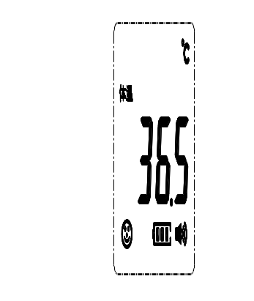

Body

Fig. 10.1

Setting of temperature unit - F1
Press and hold the “Setting” key for 2s; the screen will display F1 and the Celsius temperature icon (Fig. 10.2). Press “-” to select the (Fahrenheit) temperature unit (Fig. 10.3), and press “+” to select the (Celsius) temperature unit (Fig. 10.4).

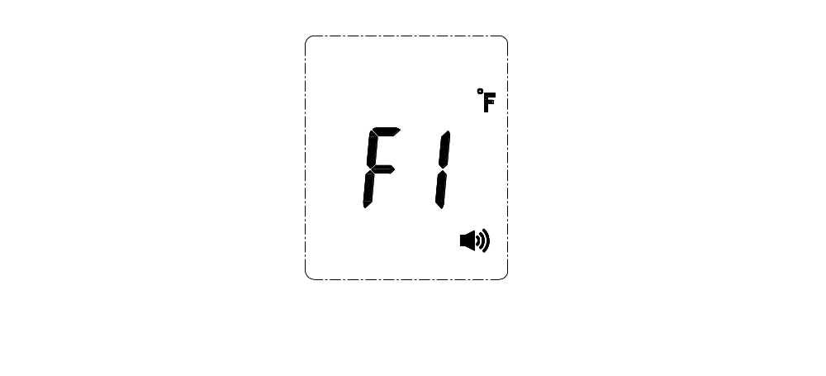
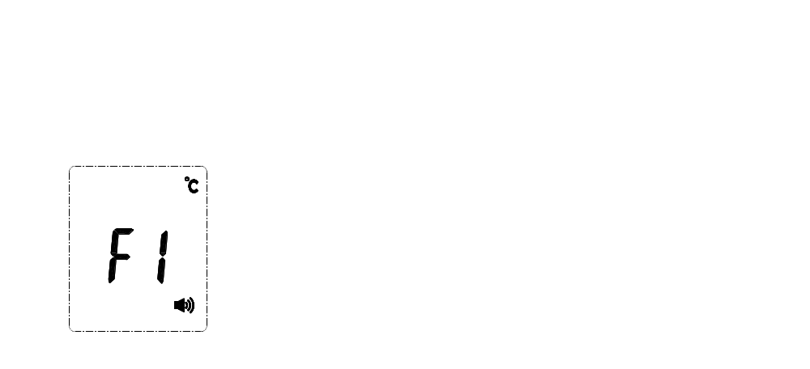

Fig. 10.2 Fig. 10.3 Fig. 10.4

Setting of temperature alarm point - F2
Press and hold the “Setting” key for 2s; the screen will display F1. Press the “Setting” key once to enter F2; then press “+” to increase the temperature value by 0.1℃ (0.1°F), and press “-” to decrease the temperature value by 0.1℃ (0.1°F). Note: The default alarm point is 38℃(100.4°F).

Setting of temperature shift - F3
Press and hold the “Setting” key for 2s; the screen will display F1. Press the “Setting” key twice to enter F3; then press “+” to increase the difference by 0.1℃ (0.1°F), and press “-” to decrease the difference by 0.1℃ (0.1°F). When the season or environment changes, it is needed to check and debug the forehead thermometer.

Setting of tone ON/OFF - F4
Press and hold the “Setting” key for 2s; the screen will display F1. Press the “Setting” key three times to enter F4. Press “+” to turn on beep sound (“OFF” will appear on the screen) or turn off beep sound (“OFF” will appear on the screen). If you need to change a certain setting after entering the setting menu, you can continuously press the menu key to select it. The new setting will be saved after operation in sequence, and will not be saved if the device shuts down in the midway.
After entering the setting menu, the measurement key will be disabled and the thermometer will not start measurement.

Tips:
1. The body temperature mode is used to measure human body temperature which is obtained by dynamic compensation of the ambient temperature and the forehead surface temperature.
Depending on the ambient temperature, measurement distance, individual skin and other factors, the measured value of temperature shift can be corrected according to the difference between the target measured value and the actual value; the correction range is -3.0℃~+3.0℃, and the factory setting is 0.0℃.
For example, if the body temperature measured with the thermometer is 36.2℃ while the actual body temperature of the measured object is 37.0℃, it will enter F3 to adjust the difference upward by 0.8℃. After setting, the result identical to the actual body temperature can be obtained.

11. Measurement Method
Confirm that the measurement mode in the upper part of the screen is body temperature mode.
Align the thermometer probe with the center of forehead at a distance of about 3-5cm and keep it vertical (see the figure below). Press the measurement key. About 1s later, a “beep” sound will be heard, and the measured value will be displayed, indicating completion of the measurement. If the measured value exceeds the temperature alarm point (default: 38℃), a sad face will be displayed; if the temperature is normal, a happy face will be displayed.
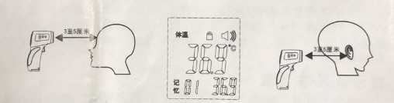
Body temperature
3-5cm
3-5cm
Memory
If the ambient temperature changes so significantly that the forehead temperature is affected, please measure the temperature by aligning the thermometer probe with the position behind the earlobe.

Tips
1. Before and after use, please keep the sensor and inner cavity of probe clean.
2. Please use the body thermometer in an environment where the ambient temperature is stable. When the ambient temperature changes significantly (e.g., from indoor to outdoor), please place the thermometer still for about 10min before measurement.
3. Do not start measuring body temperature immediately after measurement of extremely high or low physical temperature. Please place the thermometer still for about 10min before measurement.
4. If the measured object comes from a place where the ambient temperature is greatly different from the temperature in the measuring environment, it should stay in the measuring environment for at least 5min.
5. Avoid measurement when the forehead has been exposed to wind or rain, is sweating or has make-up. Do not measure the body temperature within 30min after sports, bathing or dining.

12. Battery Installation and Replacement
When the LCD displays , it indicates the battery capacity is low.
Operation:
1. Open the battery compartment cover to remove the battery.
Do not invert the anode and cathode of the battery.
Please use the specified battery; non-rechargeable battery cannot be charged.
Please remove the dry battery if it is to be left unused for a long period of time (longer than 1 month).
Do not mix new and used batteries or batteries of different types.
Used batteries after replacement should be disposed of according to local regulations.

13. Maintenance
● Please keep the sensor and the inner cavity of probe clean; otherwise the measurement accuracy will be affected.
Cleaning method:
1. Cleaning of surface: Use a clean soft cloth or cotton swab dipped with some medical alcohol or water to wipe the dirty area.
2. Cleaning of sensor and inner cavity of probe: Use a clean soft cloth or cotton swab dipped with some medical alcohol to gently wipe the inner cavity of probe or the top of sensor. The product can be used only after full volatilization of alcohol.
● Before use, please read this Product Manual carefully and confirm the battery has been installed.
● It is forbidden to soak the thermometer in any liquid, or long place it in an environment with excessively high or low temperature.
● Avoid collision, drop and mixing with sharp objects; do not attempt to disassemble the thermometer by yourself.
● Do not use the thermometer in the sunlight or in water.
● Do not use the thermometer in an environment with heavy electromagnetic interference.
● Keep the thermometer out of the reach of children.
● It is suggested to practice several times to get familiar with the measurement method; avoid changing the factory settings of the product whenever possible.
● The measurement result cannot be used in place of doctors’ diagnosis.
● No special maintenance is needed during use. In case of any failure, please contact the dealer or manufacturer.
● Please dispose of wastes and residues at the end of the service life of the product according to local laws and regulations.

14. Storage and Transportation Conditions
Storage and transportation conditions:
Temperatures: 0℃~+50℃.
RH: 10%~85% (non-condensing).
Barometric pressure: 70kPa~106kPa.
During transportation, throwing, heavy pressure, trampling and rain should be avoided. The carton should be marked with direction indication. The thermometer can be transported in a general vehicle, but must be protected against upside-down placement, violent impact, vibration, rain and snow. The thermometer should be stored in a well-ventilated room free of strong sunlight and corrosive gases in packaged state.

15. Troubleshooting

Fault | Solution
The word “LO” or “HI” appears on the screen. | 1. Check the measured person. If there is any blow, water, sweat or makeup on his/her forehead, no accurate measurement can be guaranteed.  2. Check the set value of temperature shift (factory default: 0.0).  3. Check the operating environment. Environmental changes have a great impact on the accurateness of measurement. If the ambient temperature changes too much, or the product is used to measure a low-temperature forehead immediately after measuring an ultra-high-temperature forehead, there will be measurement differences. In such case, it should be placed in a relatively stable environment for about 10min to achieve a new thermal equilibrium before measuring the next forehead.  4. Check the measuring distance (3~5cm).
Buttons do not respond. | 1. Remove and reinstall the batteries.  2. Check whether you are pressing buttons in the Setting menu.
No display or abnormal display | 1. Reinstall the batteries.
No beep sound | 1. Check whether the beep sound is set to [OFF].
Immediate shutdown after startup | 1. Check the battery level and reinstall the batteries.

16. Technical Parameters

Measurement method | Non-contact
Measurement mode | 3cm~5cm
Measurement range | 32.0℃~42.5℃（89.6°F~108.5°F）
Measurement duration | <6s
Maximum permissible error | Temperature display range | Maximum permissible error
Maximum permissible error | 32.0℃~34.9℃（89.6°F~94.8°F） | ±0.3℃（±0.5°F）
Maximum permissible error | 35.0℃~39.0℃（95.0°F~102.2°F） | ±0.2℃（±0.4°F）
Maximum permissible error | 39.1℃~42.5℃（102.4°F~108.5°F） | ±0.3℃（±0.5°F）
Resolution | 0.1℃ (°F)
Operating conditions | 16℃~35℃ (60.8°F~95°F), RH≤85% (non-condensing)
Transportation and storage conditions | 0℃~50℃ (32°F~122°F), RH≤85%
Power supply | DC 3.0V (2 AAA batteries)
Battery level indication | “Low voltage” alarm
Measurement unit | ℃ or °F
Auto power-off | Auto power-off upon 30s no-operation
Dimension | 150×84×43mm
Weight | 104g

17. Explanation for Symbols
 | Notes and warnings (refer to the attached document)
 | Fragile
 | This side up
 | No rain
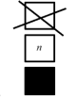 | Limit of stacking layers
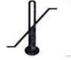 | Temperature limit for transportation of packaged product
 | Type-B applied part
 | Send to designated place for disposal

18. Warranty and After-sales Service

This product has a service life of 3 years, and will enjoy one year of free maintenance service.
Note: free maintenance service will not be provided for any damage or fault caused for the user's personal reasons or by unauthorized disassembly.
The date of manufacture is indicated on the package.

After-sales Service Provider
Name: Yichang Maochang Precision Technology Co., Ltd.
Address: No. 3, Houhe Electronic Information Industry Park, Gufu Town, Xingshan County, YichangCity.
Phone: 0717-2583525

19. List of Items
The following items have been placed into the package:
IR thermometer: 1pc Certificate of Quality: 1
7# batteries: 1 pair Warranty Card: 1
Product Manual: 1
Contact your dealer if the items you have received are different from the above list.
------------------------------------------
Warranty Card
IR Thermometer
Model No.:
Purchaser Name:
Phone:
Address:
Date of purchase:
Dealer (seal)
Note: the product must be accompanied by the Warranty Card when sent to us for repair.
------------------------------------------
Please complete the Warranty Card and cut it out along the dotted lines when sending the product for repair.

Warranty Policy
Thank you very much for your trust!
The product warranty period is one year as of the date of purchase. During the warranty period, if the product is subjected to any non-human damage, it will enjoy free maintenance service once the proof of purchase and Warranty Card are presented!
In any of the following cases, we will charge the material cost or service fee as appropriate even during the warranty period:
- No proof of purchase or Warranty Card is presented;
- The damage is caused by improper or incorrect use;
- The fault is caused by unauthorized repair or modification;
- The damage is caused by any force majeure event.
Please keep the Warranty Card for future use.

After-sales service provider: Yichang Maochang Precision Technology Co., Ltd.
Address: No. 3, Houhe Electronic Information Industry Park, Gufu Town, Xingshan County, Yichang City.
Phone: 0717-2583525

Medical Device Production License No.:
Registration Certificate No. / Technical Requirements No.:
Registrant / Manufacturer: Yichang Maochang Precision Technology Co., Ltd.
Manufacturing address: No. 3, Houhe Electronic Information Industry Park, Gufu Town, Xingshan County, Yichang City.
Phone: 0717-2583525
User’s Manual: V1.0
Prepared on: 10th March 2020.

Annex I. Statement on EMC
This product has passed the EMC test, meeting the requirements of YY0505-2012 Medical Electrical Equipment – Part 1-2: General Requirements for Safety – Collateral Standard: EMC Requirements and Tests.
In order not to cause EMI to other equipment or reduce the anti-EMI performance (or even lose the basic performance) of this product, please follow the under-mentioned requirements strictly to use this product.
As a Class-A equipment in Industrial, Scientific and Medical Equipment Group 1 defined in GB4824-2013, this product is not intended to be connected directly to the public power supply system. It is a non-permanent installation, not life support equipment.
Influence of portable and mobile RF communication equipment: portable and mobile RF communication equipment may affect the normal operation of this product, so there should be a certain space distance (see Table 4) between any portable or mobile RF communication equipment and this product.
Please contact us whenever this product has a fault. To prevent excessive EMI, do not repair or replace any component without permission.
Basic performance: the product works properly, with normal display on the screen; in the temperature measurement range of 35.0℃~42.0℃, the maximum permissible error is ±0.2℃.
WARNING:
Do not stack this product on/under or get it close to any other device. If you have to use it this way, observe and verify whether it works properly in such a condition first.
Table 1
Guidance and Statement for Electromagnetic Emissions – Non-life support equipment and system
The Infrared Thermometer is intended to work in the following electromagnetic environment. The customer or the user should assure that it is used in such an environment:
Emission Test | Compliance | Electromagnetic Environment – Guide
RF emission (CISPR 11) | Group 1 | The product uses RF energy for its internal functions only. With low RF emission, it is unlikely to cause interference to nearby electronic devices.
RF emission (CISPR 11) | Class B | The product can be used in household facilities and all facilities directly connected to household public low-voltage power supply network.
Harmonic emission (IEC61000-3-2) | N/A
Voltage fluctuation / flicker emission (61000-3-3) | N/A

Table 2
Guidance and Statement for Electromagnetic Immunity - Non-life support equipment and system
The Infrared Thermometer is intended to work in the following electromagnetic environment. The customer or the user should assure that it is used in such an environment:
Immunity Test | IEC 60601 test level | Compliance level | Electromagnetic environment – guidance
ESD  IEC61000-4-2 | ±6 kV Contact discharge  ±8 kV Air discharge | ±6 kV Contact discharge  ±8 kV Air discharge | Use wooden, concrete or tile floor only. The RH should be not less than 30% in case of composite floor.
EFT  IEC61000=4-4 | To power cord: ±2kV  To cable: ±1kVI/0 (length>3m) | N/A | The mains power supply should be of typical quality for commercial or hospital use.
Surge  IEC61000-4-5 | Difference-mode voltage: ±1kV  Common-mode voltage: ±2kV | N/A
Voltage sag, short interruption and voltage change on mains input wire  IEC61000-4-11 | < 5% UT (> 95% dip in UT) for 0.5 cycle  40% UT (60% dip in UT) for 5 cycles  70% UT (30% dip in UT) for 25 cycles  < 5% UT (> 95% dip in UT) for 5 s | N/A | The mains power supply should be of typical quality for commercial or hospital use. To ensure the continuous running of this product in case of power interruption, you can use an UPS.
PFMF (50/60Hz)IEC61000-4-8 | 3 A/m | 3 A/m | The PFMF should be of typical level and characteristics for typical areas in commercial environments or hospitals.
Note: UT is the AC mains voltage prior to application of the test level.

Table 3
Guidance and Statement for Electromagnetic Immunity - Non-life support equipment and system
The Infrared Thermometer is intended to work in the following electromagnetic environment. The customer or the user should assure that it is used in such an environment:
Immunity test | IEC60601 test level | Compliance level | Electromagnetic environment – guidance
Conducted Immuity  EC61000=4-6 | 3 Vrms  150k~80MH | N/A | Use wooden, concrete or tile floor only. The RH should be not less than 30% in case of composite floor.
Radiated immunity  IEC61000-4-3 | 3 V/m  80M~25GHz | 3 V/m | Portable and mobile RF communications equipment should be no closer to any part of the Infrared Thermometer, including cables, than the recommended separation distance calculated from the equation applicable to the frequency of the transmitter.  Recommended separation distance:  d=1.2X√P  d= 1,2 x √P 80 MHz to 800 MHZ  d= 2.3x√PF800 MHz to 2.5 GHz  P is the maximum output power rating of the transmitter in watts (W) according to the transmitter manufacturer;  d is the recommended separation distance in meters (m). Field strengths from fixed RF transmitters, as determined by an electromagnetic site survey a, should be less than the compliance level in each frequency range b. Interference may occur in the vicinity of equipment marked with the following symbol:
Note: 1. 80 MHz - 800 MHz; 2. The higher frequency band applies.
Note: These guidelines may not apply to all situations. Electromagnetic propagation is affected by absorption and reflection from structures, objects and people.
a. Field strengths from fixed transmitters, such as base stations for radio (cellular/cordless) telephones and land mobile radios, amateur radio, AM and FM radio broadcast and TV broadcast cannot be predicted theoretically with accuracy. To assess the electromagnetic environment of fixed RF transmitters, an electromagnetic site survey should be considered. If the measured field strength in where the Infrared Thermometer is located exceeds the applicable RF compliance level above, the Infrared Thermometer should be observed to verify its normal operation. If abnormal performance is observed, additional measures may be necessary, such as reorienting or relocating the Infrared Thermometer.
b. Over the frequency range of 150 K to 30 MHz, field strengths should be less than 3 V/m.
Table 4
Recommended separation distances between portable and mobile RF communications device and the Infrared Thermometer
The Infrared Thermometer is used in an electromagnetic environment in which radiated RF disturbances are controlled. The customer or the user can help prevent electromagnetic interferences by maintaining a minimum distance between portable and mobile RF communications equipment (transmitters) and the Infrared Thermometer as recommended below.
Recommended separation distances are calculated based on the maximum output power rating of the communications equipment.
Maximum output power rating of transmitter (W) | Separation distance corresponding to frequency of transmitter /m
Maximum output power rating of transmitter (W) | 150kHz-2MHz  d=1.2x √P | 80MHz-800MHz  d=1.2x √P | 800MHz-2.5GHz  d=1.2x √P
0.01 | 0.12 | 0.12 | 0.23
0.1 | 0.37 | 0.37 | 0.74
1 | 1.17 | 1.17 | 2.34
10 | 3.69 | 3.69 | 7.38
100 | 11.67 | 11.67 | 23.34

